**UML Assignment 1**

**10185101210 陈俊潼**

1. **Sol.**
2. Actors are PhD students, authorized users, professor (supervisor).
3. Use cases: course registration, thesis proposal registration, course modification, thesis proposal review, notification.

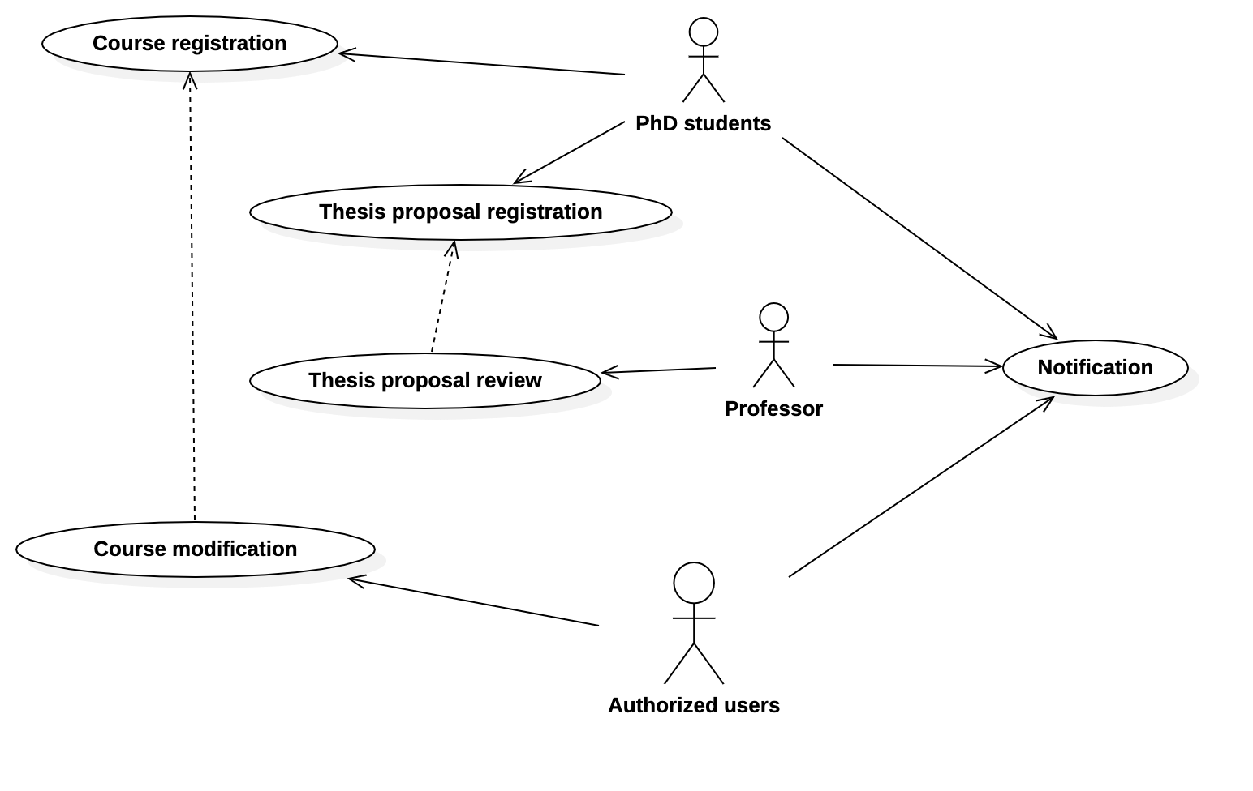

1. Details for *course registration*:

|  |  |
| --- | --- |
| **Summary** | Course registration |
| **Actor List** | PhD students |
| **Description** | The use case for PhD students to register new courses. |
| **Pre-condition** | The student has to log in first and must be a PhD student. |
| **Post-condition** | The course the students registered might be success or fail, depending on if there is available quota. |
| **Exception** | If the course is fully registered or the student is not a PhD student, the registration will fail. |

1. **Sol.**
2. Actors:
   1. Customers
   2. Booking system
3. A picture containing bottle, monitor, sitting, table

   Description automatically generated
4. Details for *queuing requests:*

|  |  |
| --- | --- |
| **Summary** | Queuing requests |
| **Actor List** | Booking system |
| **Description** | To handle with situation when multiple booking requests for a seat were sent at the same time. |
| **Pre-condition** | One or more users submitted a booking request. |
| **Post-condition** | The earliest request will be accepted, then booking system will send notification to the user. Reject rest of the requests, corresponding failing notifications will be sent as well. |
| **Exception** | If the request is for an unavailable seat or flight, this use case will throw an error. |